DAA LAB ACTIVITY – 4
Name: RATHISH P P
Roll no: CH.SC.U4CSE24238

Minimum Spanning Tree:
Prim’s algorithm:
Code:
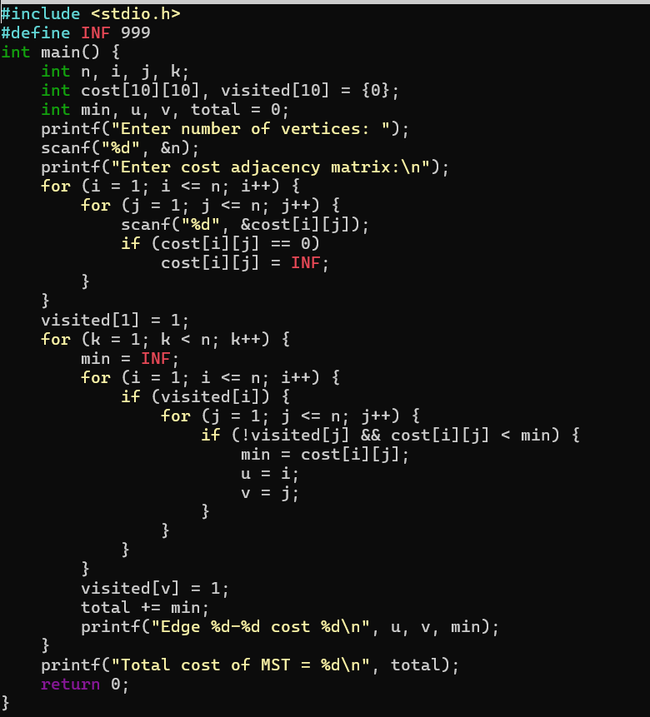
Output:
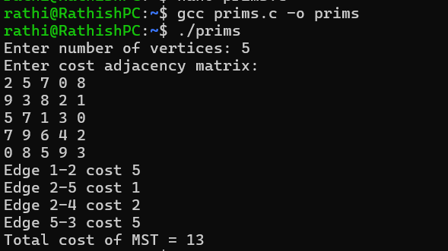

Kruskal’s Algorithm:
Code:
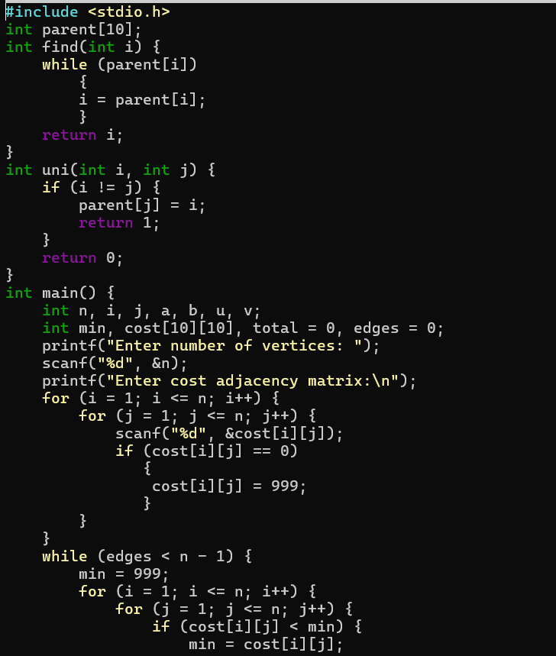
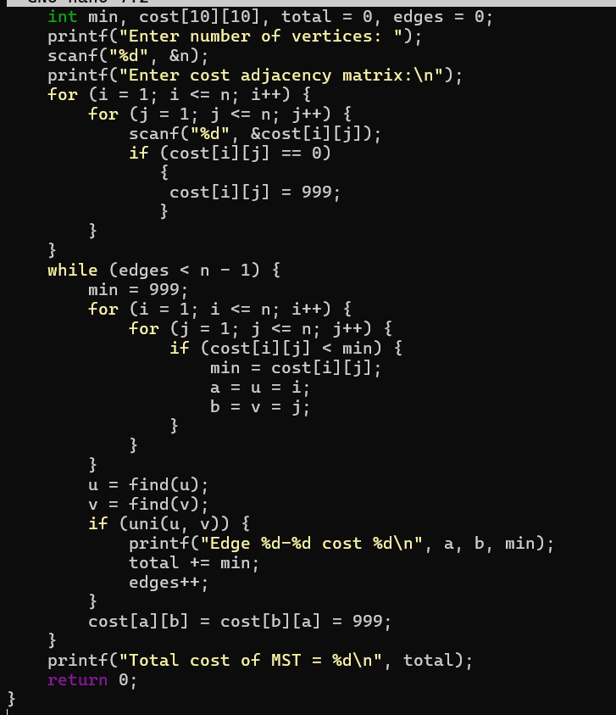
Output:
